Implicit differentiation is the process of differentiating both sides of an equation and isolating one derivative on one side of the equation. This exercise section discusses four practice problems involving implicit differentiation.

# Circle

The equation below makes the circle in Graph 1. $$x^{2}+y^{2}=25$$

1. Find $\frac{dy}{dx}$.
2. Find the tangent line that intersects $\left(3,4\right)$.

To solve (a), differentiating both sides for $x$ gives:

$\frac{d}{dx}\left[x^{2}+y^{2}\right]=\frac{d}{dx}\left[25\right]$

Graph 1

$$\frac{d}{dx}\left[x^{2}\right]+\frac{d}{dx}\left[y^{2}\right]=0$$

$$2x+\frac{d}{dy}\left(y^{2}\right)\frac{dy}{dx}=0$$

$$2x+2y\frac{dy}{dx}=0$$

$$\frac{dy}{dx}=-\frac{x}{y}$$

To solve (b), at the point $\left(3,4\right)$, the tangent to this point (slope) is

# File:Kartesisches-Blatt.svgFolium of Descartes

**Error! Reference source not found.** © 2010 Georg-Johann

Graph 2

The equation below makes the folium of Descartes (see **Error! Reference source not found.**).

$$x^{3}+y^{3}=6xy$$

1. Find $y^{'}$.
2. Find the tangent at point $\left(3,3\right)$.
3. Find the point in the first quadrant where the curve is horizontal.

To solve (a), implicitly differentiate the equation.

$$\frac{d}{dx}\left[x^{3}+y^{3}\right]=\frac{d}{dx}\left[6xy\right]$$

$$3x^{2}+3y^{2}y^{'}=6y+6xy^{'}$$

$$x^{2}+y^{2}y^{'}=2y+2xy^{'}$$

$$x^{2}-2y=\left(2x-y^{2}\right)y^{'}$$

$$y^{'}=\frac{x^{2}-2y}{2x-y^{2}}$$

To solve (b), create a line with the slope of $y^{'}$ at $\left(3,3\right)$.

$$y^{'}=\frac{{\left(3\right)}^{2}-2\left(3\right)}{2\left(3\right)-{\left(3\right)}^{2}}$$

$$y^{'}=-1$$

$$\left(y-3\right)=-1\left(x-3\right)$$

To solve (c), since horizontal lines have a slope of 0, solve the differentiated equation for $y^{'}=0$.

$$0=\frac{x^{2}-2y}{2x-y^{2}}$$

$$0=x^{2}-2y$$

$$x^{2}=2y$$

$$y=\frac{1}{2}x^{2}$$

$$x^{3}+{\left(\frac{1}{2}x^{2}\right)}^{3}=6x\left(\frac{1}{2}x^{2}\right)$$

$$x^{3}+\frac{1}{8}x^{6}=3x^{3}$$

$$\frac{1}{8}x^{6}=2x^{3}$$

$$x^{3}=16$$

$$x=2^{4/3}$$

$$y=\frac{1}{2}x^{2}=2^{5/3}$$

The point in the first quadrant where the curve is horizontal is $\left(2^{4/3},2^{5/3}\right)$.

# Trigonometric functions

Graph 3

The equation below makes Graph 3.

$$\sin\left(x+y\right)=y^{2}\cos{x}$$

Find $y^{'}$.

$$\frac{d}{dx}\left[\sin\left(x+y\right)\right]=\frac{d}{dx}\left[y^{2}\cos{x}\right]$$

$$\cos\left(x+y\right)⋅\frac{d}{dx}\left(x+y\right)=y^{2}\left(-\sin{x}\right)+\left(\cos{x}\right)\left(\frac{d}{dx}y^{2}\right)$$

$$\cos\left(x+y\right)⋅\left(1+y^{'}\right)=y^{2}\left(-\sin{x}\right)+\left(\cos{x}\right)\left(2yy^{'}\right)$$

# Fat Circle

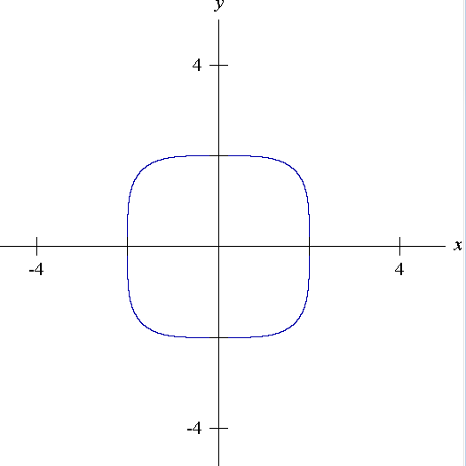The equation below makes a fat circle (See Graph 4).

$$x^{4}+y^{4}=16$$

Find $y''$.

Graph 4

$$\frac{d}{dx}\left[x^{4}+y^{4}\right]=\frac{d}{dx}\left[16\right]$$

$$4x^{3}+4y^{3}y^{'}=0$$

$$y^{'}=-\frac{x^{3}}{y^{3}}$$

$$\frac{d}{dx}y^{'}=\frac{d}{dx}\left[-\frac{x^{3}}{y^{3}}\right]$$

$$y''=-\frac{y^{3}\left(3x^{2}\right)-x^{3}\left(3y^{2}y^{'}\right)}{{\left[y^{3}\right]}^{2}}$$

$$y''=-\frac{y^{3}\left(3x^{2}\right)-x^{3}y^{2}\left(-\frac{x^{3}}{y^{3}}\right)}{y^{6}}$$

$$y''=-\frac{y^{4}\left(3x^{2}\right)+3x^{6}}{y^{7}}$$

$$y''=-\frac{3x^{2}\left(x^{4}+y^{4}\right)}{y^{7}}$$

$$y''=-\frac{3x^{2}\left(16\right)}{y^{7}}$$

$$y''=-\frac{48x^{2}}{y^{7}}$$